VEGAN & VEGETARIAN

The production of animal products has a multitude of negative impacts. It requires huge amounts of resources such as water and land, climate change is accelerated and biodiversity is reduced. Additionally, the consumption of animal products raises ethical questions (Swissveg, 2022)
¹ https://govegan.ch/de/warum

A large share of the nutrients and energy are lost during the detour through the animal’s digestive system. Animal products require 83% of global farmland, but provide only 18% of calories and 37% of protein consumed globally (Poore & Nemecek, 2018).
² Poore, J., Nemecek, T. ‘Reducing food’s environmental impacts through producers and consumers’, Science 360 (2018)
At the same time, one in ten people still suffers from chronic hunger (Welthungerhilfe, 2020).
³ https://www.welthWWFungerhilfe.de/hunger/#c7550

The footprint of an average Swiss person’s diet is reduced by 24% by going vegetarian, and 40% by going vegan (WWF).
⁴ https://www.wwf.ch/de/unsere-ziele/fleisch-und-milchprodukte

According to the UN Food and Agriculture Organization, livestock production is responsible for 14.5% of global greenhouse gas emissions (FAO).
⁵ https://www.fao.org/news/story/en/item/197623/icode/
Beef causes 30 times as much greenhouse gas emissions per gram of protein as tofu (Poore & Nemecek, 2018).
⁶ Poore J., Nemecek, T. ‘Reducing food’s environmental impacts through producers and consumers’, Science 360 (2018)

Illustration:
1 kg beef: 15’400 L water
1 kg rice: 2’500 L water
1 kg potatoes: 290 L water
⁷ https://www.waterfootprint.org/en/resources/interactive-tools/product-gallery/
----
SEASONAL & REGIONAL
The footprint of produce depends on many factors, including cultivation method, transportation, and storage. Buying regional and seasonal foods is an easy way to avoid resource- and emission-intensive products (WWF).
¹ https://www.wwf.ch/de/unsere-ziele/fruechte-und-gemuese
On top of that you are supporting local markets.

Little Infobox:
Did you know? Champignons are in season all year round in Switzerland!
Tip: Put a seasonal calendar on your fridge.
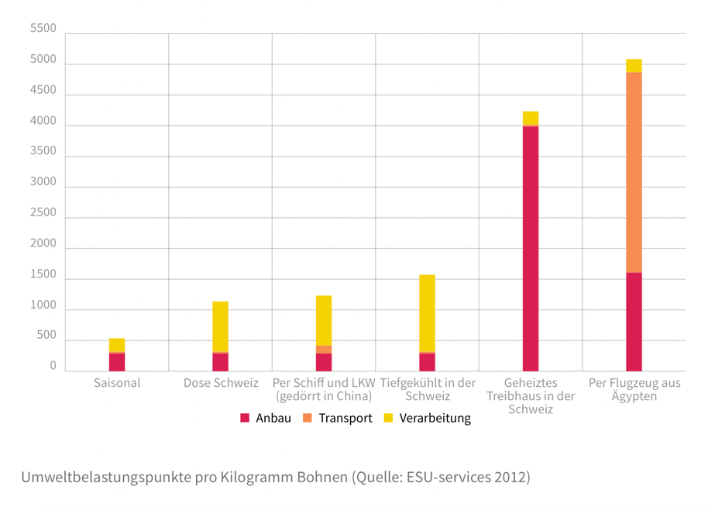
Overall, the means of transport plays a bigger role than the transport distance. Transport by ship or rail has a smaller environmental impact than transport by air.
The sustainable choice is to buy seasonal and regional fruits and veggies rather than airborne goods or food from fossil-fuel heated greenhouses. This will reduce your environmental impact from produce by a factor of eight to ten (WWF, Eaternity).
¹ https://www.wwf.ch/de/unsere-ziele/fruechte-und-gemuese, ESU Service 2012
² https://eaternity.org/assets/smart-chefs/2018-09-06-Eaternity-Compilation.pdf
ORGANIC

Environmental sustainability should be hold up through organic farming. Farming practices are adapted for holistic soil and nutrient management.
Like any production system, organic farming has trade-offs and synergies within environmental, social and economic dimensions (FiBL, 2022).
Organic sales grew strong in 2020, like in the years before.
In Switzerland the consumers spend the most on organic food. About 420 euros per capita, while the biggest markets are found in the US and Germany. In India there are the most producers that go for organic production. Still the percent of farmland, that is farmed organically all over the world is only 1.6 percent (FiBL, 2022).
^{1,2,4} https://www.fibl.org/en/info-centre/news/global-organic-market-unprecedented-growth-in-2020

The goal of organic farming is that Biodiversity is increased through careful cultivation methods and compensation areas. This is also reason for people to buy organic. In addition, Swiss people mention that is important for them that there is species-appropriate animal husbandry, less pesticide, and a reduced use of antibiotics in livestock farming (Biobarometer Switzerland, 2018).
What keeps consumers from buying more organic food?
The price is the biggest factor (Biobarometer Switzerland, 2018).
³ https://www.fibl.org/de/themen/projektdatenbank/projektitem/project/1505

Challenge:
One criticism of organic farming is that it is not efficient and therefore climate friendly. For the same amount of food, a larger area of land is needed than in conventional farming (FiBL, 2022).

Packaging
Large quantities of packaging materials are used for the storage, transport and consumption of food. From production to disposal or recycling of the materials, many resources and energy are required. If these materials are not disposed of properly, they end up in ecosystems and pollute them (Ecowatch, 2021).

Each year, despite conservation efforts, 8 million tons of plastic reaches our oceans to meet the 150 million metric tons of plastic that already exists in marine environments. The production of plastic in 2020 was over 360 million metric tons, recycled plastics not included. The overall Tendency is upwards (Plastics Europe, 2021).
¹ https://plasticseurope.org/wp-content/uploads/2021/12/Plastics-the-Facts-2021-web-final.pdf
Half of this plastic is single use. Of the plastic we use globally, only around 9% of it gets properly recycled (Ecowatch, 2021).
² https://www.ecowatch.com/ocean-plastic-guide-2653277768.html

The soft drink industry in particular creates tons of plastic waste. In 2016, Coca-Cola produced over 110 billion single-use plastic bottles. (Greenpeace, 2021)
³ https://www.greenpeace.ch/de/medienmitteilung/75375/die-groessten-plastikverschmutzer-der-welt-coca-cola-pepsi-unilever-und-nestle-2/
Affects Marine Life, and comes back to humans trough the food chain
(Ocean Portal Team, 2018).
⁴ https://ocean.si.edu/conservation/pollution/marine-plastics
Impacts climate change, as plastic is made of oil, it is estimated that by 2050 plastics need 20% of the oil production
⁶ (https://yaleclimateconnections.org/2019/08/how-plastics-contribute-to-climate-change/)
Also a really big problem is the disposal of fishing gear. It is the biggest factor in plastic pollution in the oceans (Greenpeace).
⁵ https://www.greenpeace.ch/de/medienmitteilung/75375/die-groessten-plastikverschmutzer-der-welt-coca-cola-pepsi-unilever-und-nestle-2/

What can we do? Use the 5 R, and if you want to go further step by step you can use tips like from https://zerowastehome.com/tips/
Bild 5R
⁷ https://zerowasteswitzerland.ch/en/about-us/zero-waste-initiative/
Food Waste
In Switzerland, 2.8 million tons of food are lost per year. About two thirds of this is avoidable. The disposal leads to losses of 600 francs per person/year (savefood.ch). For the whole of Switzerland, this is an extrapolated 5 billion francs 2 (Beretta & Hellweg, 2019).
Land consumption for growing discarded food along the entire value chain is equivalent to half of Switzerland's agricultural land (BAFU).
Food waste (avoidable food losses) accounts for 25 percent of the environmental impact of Switzerland's food supply. This corresponds to about half the environmental impact of Switzerland's private motorized transport (BAFU).
The food categories with the greatest environmental impact per kilogram of food waste are meat, coffee and cocoa beans, butter, eggs, products imported by air, oils and fats, fish and cheese. Still veggies are also relevant, because they are are thrown away in large numbers (BAFU).
Around half of of the environmental impact from Food Waste is generated by households and in restaurants. Food Waste has a higher impact at the end of the value chain. Ever production step more resources and emissions are caused. (Transport, processing, storage, packaging and preparation) (BAFU).
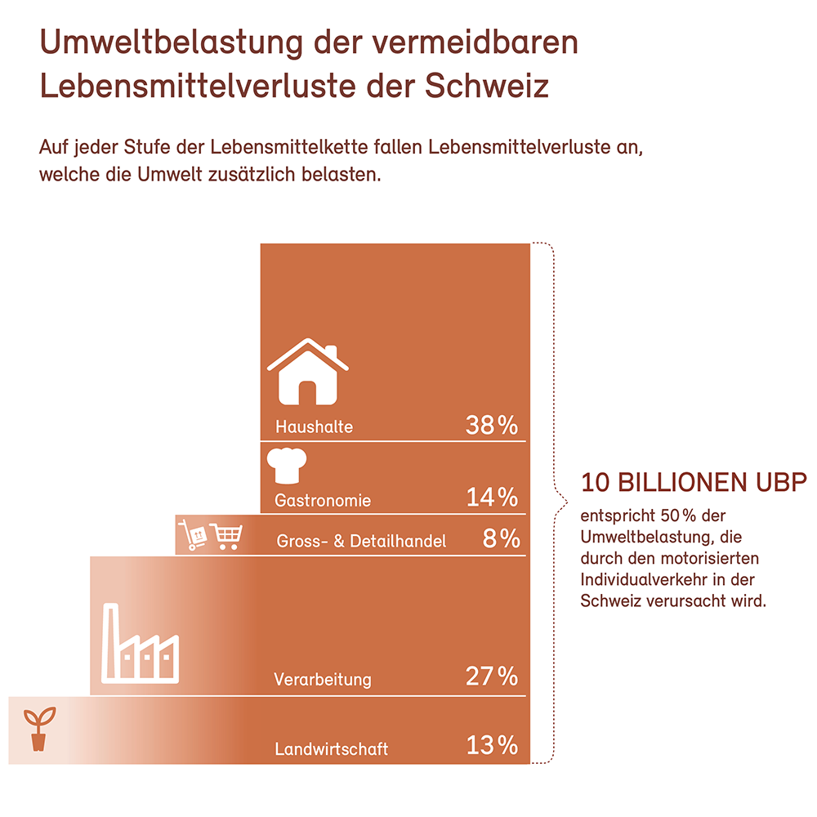 Umweltbelastungspunkte (UBP)

Picture: Environmental impact of food losses along the Swiss food value chain in trillion environmental impact points (EIP). This includes losses in foreign supply chains of food consumed in Switzerland (consumer perspective). The percentages show the contributions of the individual stages of the food chain (BAFU, 2021).
https://www.bafu.admin.ch/bafu/de/home/themen/abfall/abfallwegweiser-a-z/biogene-abfaelle/abfallarten/lebensmittelabfaelle.html
Beretta, C. and Hellweg, S. (2019) Lebensmittelverluste in der Schweiz: Umweltbelastung und Verminderungspotenzial. Wissenschaftlicher Schlussbericht. https://www.newsd.admin.ch/newsd/message/attachments/58769.pdf

5 Schritte : foodwaste.ch
1. Kaufe nur soviel du brauchst (Kaufe mit Plan ein)
2. Lagerung: Verlängere die Haltbarkeit durch richtige Lagerung
3. Richtige Portionen - kleinere Mengen kochen und servieren
4. Spass am Kochen – kreativ sein und Neues ausprobieren
5. Gemeinsam geniessen, weil du dein Essen liebst

